**Module (CSS and CSS 3) -2**

• What are the benefits of using CSS?

There are a number of benefits of CSS, including:

**1) Faster Page Speed**

More code means slower page speed. And CSS enables you to use less code. CSS allows you to use one CSS rule and apply it to all occurrences of a certain tag within an HTML document.

**2) Better User Experience**

CSS not only makes web pages easy on the eye, it also allows for user-friendly formatting. When buttons and text are in logical places and well organized, user experience improves.

**3) Quicker Development Time**

With CSS, you can apply specific formatting rules and styles to multiple pages with one string of code. One cascading style sheet can be replicated across several website pages. If, for instance, you have product pages that should all have the same formatting, look, and feel, writing CSS rules for one page will suffice for all pages of that same type.

**4) Easy Formatting Changes**

If you need to change the format of a specific set of pages, it’s easy to do so with CSS. There’s no need to fix every individual page. Just edit the corresponding CSS stylesheet and you’ll see changes applied to all the pages that are using that style sheet.

**5) Compatibility Across Devices**

Responsive web design matters. In today’s day and age, web pages must be fully visible and easily navigable on all devices. Whether mobile or tablet, desktop, or even smart TV, CSS combines with HTML to make responsive design possible.

• What are the disadvantages of CSS?

## ****Disadvantages of CSS****

There are a few downsides while using CSS. One must know these disadvantages so that he or she is aware and takes care of them while designing a website.

### ****1. Confusion due to many CSS levels****

Beginners are more vulnerable to this issue. They might get confused while opting to learn CSS as there are many levels of CSS such as CSS2, CSS3, etc.

### ****2. Cross-Browser Issues****

Different browsers work differently. So, you have to check that changes implemented in the website via CSS codes are reflected properly among all browsers.

### ****3. Security Issues****

Security is important in today’s world driven by technology and data. One of the major disadvantages of CSS is that it has limited security.

### ****4. Extra Work for Developers****

Design services are required to consider and test all CSS codes across different browsers for compatibility. Due to developers testing compatibility for different browsers, their workload increases.

Overall, we can say that if you are passionate about web development, try to learn HTML and CSS. For device compatibility, learn the Bootstrap framework as well. Though you might see some disadvantages of CSS, many advantages counter them and ensure that your web development process is smooth and efficient.

• What is the difference between CSS2 and CSS3?

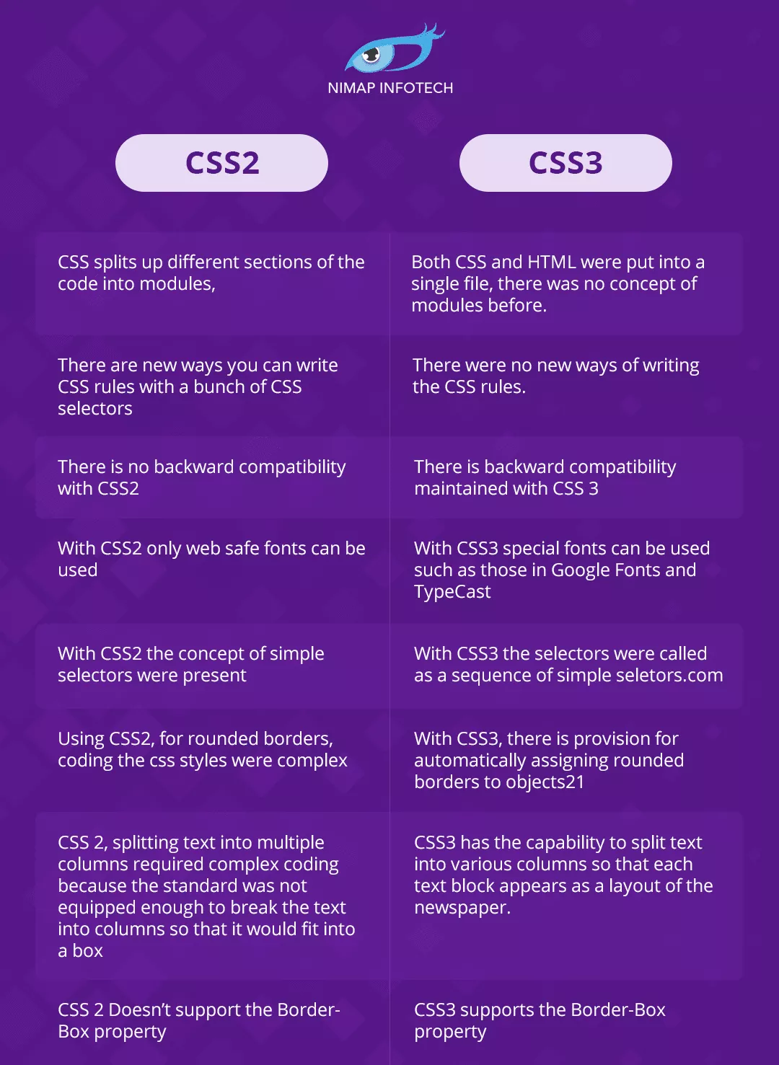

• Name a few CSS style components

**The components of css style are:**  
  
**Selector:** class name, id name or element name that is target  
**Attribute:** name of the attribute you want to style for example border, color,background, position etc.  
**Value of Property:** value that will be assigned to attribute.

• What do you understand by CSS opacity?

A [<number>](https://developer.mozilla.org/en-US/docs/Web/CSS/number) in the range 0.0 to 1.0, inclusive, or a [<percentage>](https://developer.mozilla.org/en-US/docs/Web/CSS/percentage) in the range 0% to 100%, inclusive, representing the opacity of the channel (that is, the value of its alpha channel). Any value outside the interval, though valid, is clamped to the nearest limit in the range.

| **Value** | **Meaning** |
| --- | --- |
| 0 | The element is fully transparent (that is, invisible). |
| Any [<number>](https://developer.mozilla.org/en-US/docs/Web/CSS/number) strictly between 0 and 1 | The element is translucent (that is, content behind the element can be seen). |
| 1 (default value) | The element is fully opaque (visually solid). |

• How can the background color of an element be changed?

The *value* of the *background-color* property can be specified in three ways:

1. Using *RGB values* e.g. rgb(250,0,0), rgb(0,250,0), etc.
2. Using a *Hexadecimal(HEX) value* e.g. #FFFFFF, #000000, etc.
3. Using a valid *color name* e.g. “white”, “red”, “black”, “blue”, etc.

• How can image repetition of the backup be controlled?

The **background-repeat property** in CSS is used to repeat the background image both horizontally and vertically. It also decides whether the background image will be repeated or not.

**Syntax:**

background-repeat: repeat|repeat-x|repeat-y|no-repeat|initial|inherit;

• What is the use of the background-position property?

The **background-position** property in CSS is mainly used to sets the initial position for the background image ie., it is used to set an image at a certain position. The position that is relative to the positioning layer, can be set by using the [background-origin](https://www.geeksforgeeks.org/css-background-origin-property/) property.

**Syntax:**

background-position: value;

**Note:**The [background-image](https://www.geeksforgeeks.org/css-background-image-property/) is placed default to the top-left corner of an element with a repetition on both horizontally & vertically.

• Which property controls the image scroll in the background?

The background-attachment property sets whether a background image scrolls with the rest of the page, or is fixed.

This way to controls background-image

background-attachment: scroll|fixed|local|initial|inherit;

• Why should background and color be used as separate properties?

Why background and color are the separate properties if they should always be set together? There are two reasons behind this: It enhances the legibility of style sheets. The background property is a complex property in CSS, and if it is combined with color, the complexity will further increase.

• How to center block elements using CSS1?

Ans.

1.Set a fixed width for the block element you want to center.

Apply margin-left: auto; and margin-right: auto; to the block element.

Syntax :-

.block-element {

width: 300px; /* Set a fixed width */

margin-left: auto; /* Center horizontally */

margin-right: auto; /* Center horizontally */

}

It's important to note that this method works for block elements with a fixed width. If the block element has a width of 100% or is a flexible container, alternative methods such as using flexbox or CSS Grid are more appropriate for centering.

2. It can be done by the use of table like:

Table {margin-left: auto; margin-right: auto; width: 400px;}

This table width is being defined by the content used.

These are the methods that are used to center the block element.

• What are different ways to integrate a CSS into a Web page?

Ans.

There are three ways to integrate CSS into a Web page

1) Inline : HTML elements may have CSS applied to them via the STYLE attribute.

2) Embedded : By placing the code in a STYLE element within the HEAD element.

3) Linked/ Imported : Place the CSS in an external file and link it via a link element.

• What is embedded style sheets ?

Ans.

Embedded style is inside the HTML code only. It is written using the <Style> tag and used under the <Head> structure. It gets applied to the element for which the style will be written.

Syntax :-

<head>

<style>

p{text-indent: 10pt;}

h1{text-color: #ffffff;}

</style>

</head>

• What are the external style sheets?

Ans.

External style sheet are made up of css format only, it contains style information that can be linked with the HTML document externally. It is one of the easy and structured way as it keeps the style separate from the structure. It is a convenient way as only one file will be affected if any changes will be made overall. The file is linked through Link tag used inside the HTML Head.

Syntax:- Add this link in <head> element.

<link rel=stylesheet href="style.css" type="text/css">

• What are the advantages and disadvantages of using external style sheets?

Ans.

The advantages of External Style Sheets are:

1. Using them, the styles of multiple documents can be controlled from one file.

2. Classes can be created for use on multiple HTML element types in many documents.

3. In complex situations, selector and grouping methods can be used to apply styles.

The disadvantages of External Style Sheets are:

- In order to import style information for each document, an extra download is needed.

- Until the external style sheet is loaded, it may not be possible to render the document.

- For small number of style definitions, it is not viable.

• What is the meaning of the CSS selector?

Ans.

CSS selectors are patterns used to target HTML elements for styling.

They include element, class, ID, attribute, and pseudo-class selectors.

Selectors can be combined to create more specific targeting.

Selectors like descendant and adjacent sibling select elements based on their relationship with other elements.

CSS selectors provide flexibility in styling and selecting elements on webpages.

• What are the media types allowed by CSS?

Ans.

CSS supports media types such as "screen" for computer screens and "print" for printed documents, allowing different styles to be applied based on the device or medium.

All media (all): The default media type that applies to all devices.

• What is the rule set?

Ans.

In CSS, a rule set consists of one or more CSS rules that define how specific elements should be styled. A rule set typically includes a selector and a declaration block.

A CSS file can contain multiple rule sets, allowing you to define different styles for different elements or groups of elements on a webpage.